Water Sensor
Pin description:
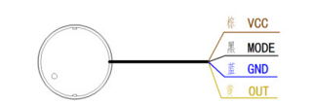

Intelligent non-contact liquid level sensor uses advanced signal processing technology and high-speed signal processing chip, to achieve the real non-contact detection of the liquid level in a closed container.The liquid level sensor (probe) can be installed on the upper and lower sides of the outer wall of the measured container (the high and low level of the liquid level). Non-metallic containers do not need to open a hole, and it is easy to install.
Can detect liquid level of toxic substances, strong acid and alkali and a variety of liquid in the high-pressure sealed container.
Features:
- Operating voltage: 4.8-24VDC
- Operating current: <= 5 mA
- Output: high and low output, the default settings, when it senses the liquid, it outputs high, otherwise the output is low.
- Compatibility: can penetrate a variety of non-metallic materials such as plastic, glass, ceramic, sensing distance of up to 12mm
- Pin Description: Brown (VCC) connected to the power supply positive, yellow (OUT) is the signal output, blue (GND) connected to the power supply negative. Black line is a valid level selection, if it is connected to high or floating, the active level is high. Otherwise, the active level is low.
- Sensitivity adjustment: open the sensor head back cover, adjust the sensitivity knob with a small screwdriver, Counterclockwise rotation increases the sensitivity and clockwise rotation reduces sensitivity.

Sensitivity adjustment:
Turn counterclockwise to increase sensitivity.
Turn clockwise to reduce sensitivity.
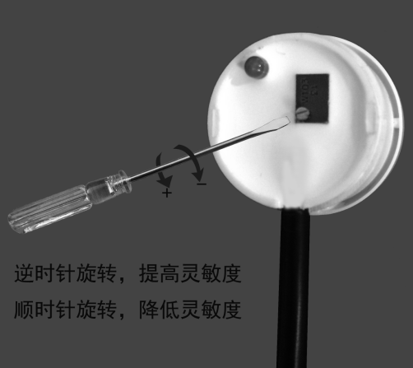

Dimensions:
